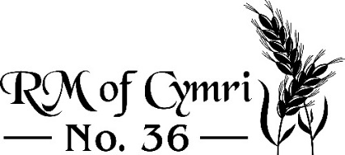 Established 1909
________________________________________________________________________

Gopher Bounty 2023 – Submission Form

Date:

Name:

Phone number:

Gopher land location:

Mailing Address:

Town: Postal Code:

# of tails: x $0.25/tail =

Trapper Signature:

RM Signature:

