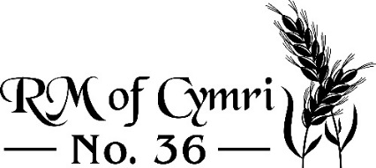 Established 1909
________________________________________________________________________

Coyote Bounty 2023 – Submission Form

Date:

Name:

Phone number:

Land location where hunted:

Mailing Address:

Town: Postal Code:

Set of 4 paws: x $20.00/set =

Trapper Signature:

RM Signature:

